- In a completed study, there is a known population with a normal distribution, Population M = 128, and Population SD = 10. What is the estimated effect size if a sample given an experimental procedure has a mean of
(a) 130,
(b) 133,
(c) 136,
(d) 128?
For each part, also indicate whether the effect is approximately small, medium, or large (Please use
the Cohen’s effect size conventions).

- You are planning a study that you determine from a power table as having quite low power. Name six things that you might do to increase power.

- Suppose you are a candidate running for the brand manager claims that you will reduce the average time of creating the new brief for the campaign to less than 60 minutes, which is thought to be the average response time with the current brand manager. There are no past records, so the actual standard deviation of such response times cannot be determined. Congratulations, finally you are selected to be the new brand manager, and careful records are now kept. The response times for the first month for 10 campaigns are 52, 60, 56, 58, 50, 56, 64, 70, 48, and 46 minutes. Using the .05 significance level, did you keep your promise? Go through the five steps of hypothesis testing.
  - Restate the question about the research hypothesis and a null hypothesis about the populations.
  - Determine the characteristics of the comparison distribution
  - Determine the significance cutoff.
  - Determine your sample’s score on the comparison distribution.
  - Decide whether to reject the null hypothesis.

- There is a social marketing campaign to reduce on using plastic bag in four group : Marketing Communication Students, PR Students, Journalism Students and Employees of University. A campaign was conducted three months, starting on January 2021 until March 2021. The amount of plastic bags was measured before the program was started and then after March 2021. The results were as follows:

Categories | Before Campaign (Kg) | After campaign (Kg)
MarComm Students | 18 | 4
PR Students | 20 | 8
Journalism Students | 16 | 10
Employees of University | 18 | 2
Using the .05 level of significance, was there a significant decrease in using of plastic bag? Use the five steps of hypothesis testing.
  - Restate the question about the research hypothesis and a null hypothesis about the populations.
  - Determine the characteristics of the comparison distribution
  - Determine the significance cut off.
  - Determine your sample’s score on the comparison distribution.
  - Decide whether to reject the null hypothesis.

- A study of effects of using endorsers on likeness compared likeness test scores of participants who watched the advertisement on either with celebrities or politicians as an endorser. The scores of five participants who watched the advertisement with politicians as an endorser were 13, 15, 24, 17 and
14. The scores for four participants who watched the advertisement with celebrities as endorser were 21, 27, 18 and 25. Using the .05 level, one tailed (predicting lower likeness scores for the politicians as an endorser of the Ad.). Use the steps of hypothesis testing:
- Restate the question about the research hypothesis and a null hypothesis about the populations.
- Determine the characteristics of the comparison distribution
- Determine the significance cut off.
- Determine your sample’s score on the comparison distribution.
- Decide whether to reject the null hypothesis.

- One of student Bakrie University conducted the research to compare the effects of four social media platform on small business scale. He selected 20 participants for each group (there are 4 groups) and then assessing their effects of sales on standard measure. The results are as follows.
Group 1, using Instagram: M = 16, S² = 20, Group 2, using facebook: M = 13, S² = 25 Group 3, using Youtube: M = 19, S² = 14 Group 3, using Tiktok: M = 16, S² = 27

Use the five steps of hypothesis testing (and the 0,05 significance level) to determine whether the effect of using social media.
  - Restate the Question as a Research Hypothesis and a Null Hypothesis about the Populations Population 1 :
Population 2 :
Hnull (Ho) :
Hresearch (H1) :
  - Determine the Characteristics of the Comparison Distribution:
  - Determine the Cutoff Sample Score on the Comparison Distribution at Which the Null Hypothesis Should Be Rejected:
  - Determine Your Sample’s Score on the Comparison Distribution:
  - Decide Whether to Reject the Null Hypothesis:

- One of lecturer of Statistics wanted to know the effect of new grading system on Statistics Course. From previous years, the expected distribution of the scores roughly follows a normal curve on the final exam of Statistics in which
the highest scoring 3% of students get As; the next highest scoring 15%, Bs;
the next 66%, Cs; the next 15%, Ds;
and the lowest scoring 3%, Fs.
A class take the a final exam of Statistics using a new grading system and, 15 get As;
39 get Bs;
145 get cs,
15 get Ds, and 11 get Fs.
Use the steps of hypothesis testing to decide whether the new grading system produces a different distribution of grades (using the .01 level).

- The government had a plan to do the “lockdown” the city because of the second wave of COVID 19. A communication specialist is interested to do the survey whether the district in which person lives is related to person’s opinion on the “lockdown” plan. The survey is conducted via phone to 90 people who live in three different districts. The results are shown in the following table. Is opinion related to the district at .05 level? To answer this question please carry out the five steps of hypothesis testing. An also compute Cramer’s phi and power.
Opinion | District 1 | District 2 | District 3
Agree | 13 | 5 | 5
Disagree | 16 | 4 | 14
No opinion | 13 | 9 | 11

- Please find, and explain the most important information from these SPSS output tables:
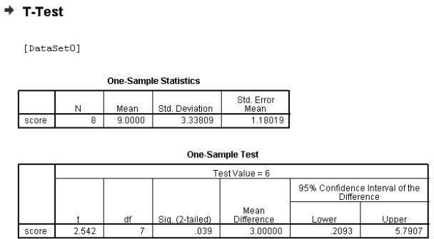
- The study used the .05 significance level.

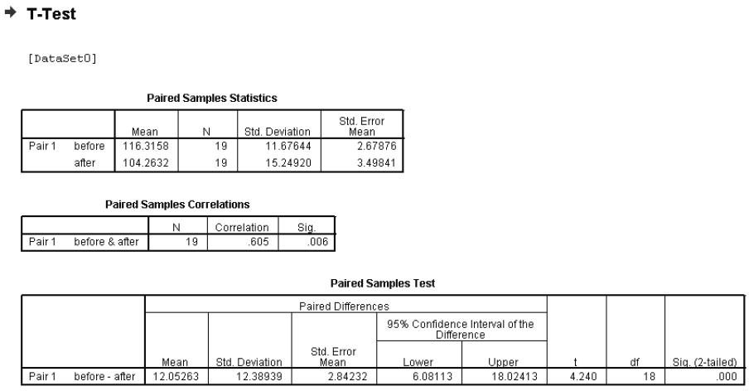
- The study used the .05 significance level.

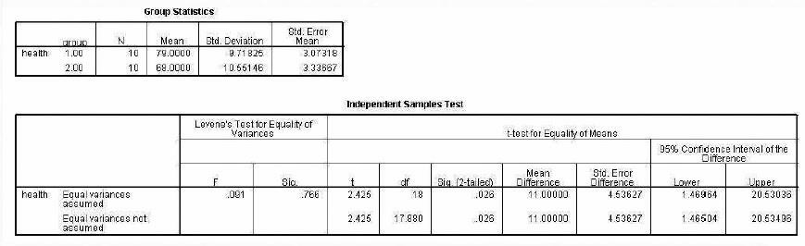
- The study used the .05 significance level.
- The study used the .05 significance level.
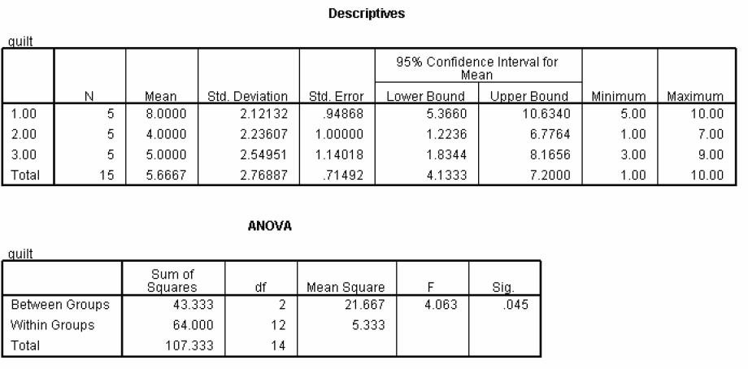

- Please find, and explain the most important information from these SPSS output tables:
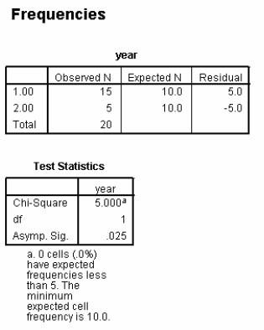
- The study used significance level .05.
- The study used the .05 significance level.


