PENIMBANGAN
- Suspensi
Replikasi 1 = 125,4 mg
Replikasi 2 = 125,5 mg
- Pemanansan
Replikasi 1 = 125,5 mg
Replikasi 2 = 125,6 mg
PERHITUNGAN KONSENTRASI SAMPEL
 | Replikasi 1 | Replikasi 2
Suspensi | $\frac{125,4 mg}{10 ml}×1000=12540 ppm$  Ditotolkan 2 µl 2 µl $×$ $\frac{12540 ng}{µl}=25080 ng$ | $\frac{125,5 mg}{10 ml}×1000=12550 ppm$  Ditotolkan 2 µl 2 µl $×$ $\frac{12550 ng}{µl}=25100 ng$
Pemanasan | $\frac{125,5 mg}{10 ml}×1000=12550 ppm$  Ditotolkan 2 µl 2 µl $×$ $\frac{12550 ng}{µl}=25100 ng$ | $\frac{125,6 mg}{10 ml}×1000=1256 ppm$  Ditotolkan 2 µl 2 µl $×$ $\frac{12560 ng}{µl}=25120 ng$

KADAR SAMPEL
y = 5,813x + 1469
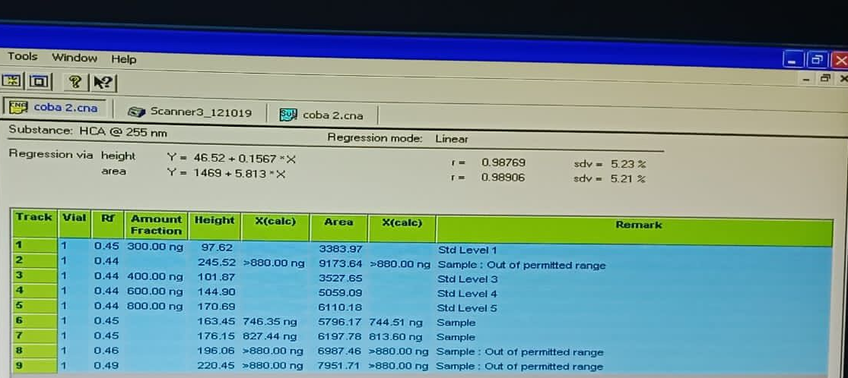
 | Replikasi 1 | Replikasi 2
Suspensi | Y = 5796,17  y = 5,813x + 1469  5796,17 = 5,813x + 1469  X = 744,395 ng  Kadar sampel  $\frac{744,395 ng}{25080 ng}×100 \%=2,97 \%$ | Y = 6197,78  y = 5,813x + 1469  6197,78 = 5,813x + 1469  X = 813,484 ng  Kadar sampel  $\frac{813,484 ng}{25100 ng}×100 \%=3,24 \%$
Pemanasan | Y = 6987,46  y = 5,813x + 1469  6987,46 = 5,813x + 1469  X = 949,252 ng  Kadar sampel  $\frac{949,252 ng}{25100 ng}×100 \%=3,78 \%$ | Y = 7951,71  y = 5,813x + 1469  7951,71 = 5,813x + 1469  X = 1115,210 ng  Kadar sampel  $\frac{1115,210 ng}{25120 ng}×100 \%=4,44 \%$

